|  |  |
| --- | --- |
| **Practicum Case** |  |
| CPEN6098 | CPEN6108 | CPEN6109  Computer Networks |
| **Computer Engineering** | **O1-CPEN6098-CP01** |
| ***Valid on*** *Even Semester Year 2018/2019* | **Revision 00** |

## Learning Outcomes

* Describe basic structures of network
* Explain concepts of create network environment

## Topic

* Session 07 - VLAN

## Sub Topics

* Creating VLAN
* VLAN Trunk technique
* Introduction to telnet or SSH

## Soal

*Case*

**VLAN** is a LAN management to reduce the cost of using network devices and for the example, one switch can be attached by severals network ID and very usefull for some security reasons. When using VLAN, the broadcast data only in same network and not to another different network. There are many types of VLAN based on the functions:

1. **Default VLAN**, the configured LAN at the first boot of switch and attached on all port of switch. This VLAN cannot be removed or edited.
2. **Native VLAN**, using a 802.1Q concept and the default VLAN was a Native VLAN on all switch. Native VLAN can be defined with any VLAN.
3. **Data VLAN**, the normal VLAN that client data through the LAN
4. **Voice VLAN**, is configured with QOS policies to prioritize the traffic. Voice LAN carries the voice traffic through the data.
5. **Management VLAN**, is used to manage the LAN setting through the access to chosen client as a admin.

There are the case example:

**Network Net Coorporation** want to build a new network. They want to use **VLAN technologies** because there are costless, more secure, and easy to manage the small LAN. They network devices to build their LAN are **3 switches** and **18 computers**. The details to build that LAN are:

* **Network Net Coorporation** have **3 floor** building to build 1 LAN.
* **Network Net Coorporation** have **three division** with each division have different **Network ID**:
  + **Operational Division** with the given address range **185.10.0.0** – **185.10.255.255** with VLAN ID: **VLAN 10**
  + **Finance Division** with the given address range **190.10.0.0** – **190.10.255.255** with VLAN ID: **VLAN 20**
  + **IT Support** with the given address range **197.125.10.0** – **197.125.10.255** with VLAN ID: **VLAN 30**
* Each floor must have **1 switch** to connecting **each computer** and **another switch** from another floor.
* At first floor have 3 computers for **Operational**, 2 computers for **IT Support**, and 2 computers for **Finance**.
* At second floor have 2 computers for **Operational** and 2 computers for **Finance**.
* At third floor have 2 computers for **Operational**, 2 computers for **IT Support**, and 3 computers for **Finance**.
* Give **telnet** access to **IT Support** division to manage VLAN.

As a **network support and** **administrator**, they requests to create LAN with 3 different network address that can ping with same division in each floor, but they can send data to other network or division. For the example see the picture below:

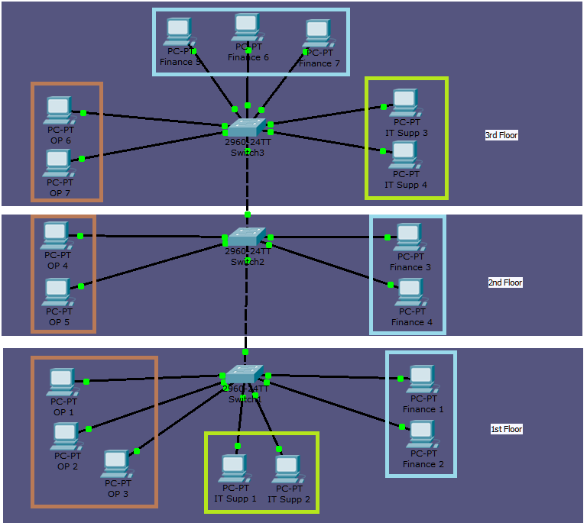

**If you don’t understand, please ask to your assistant!**